Problem 3.Compute (derive math formulas) the autocorrelation of the triangular pulse

1. Compute (derive math formulas) the autocorrelation of the triangular pulse



|  |  |  |
| --- | --- | --- |
| 1 |  |  |
| 2 |  |  |
| 3 |  | |
| 4 |  | |
| 5 |  |  |
| 6 |  |  |

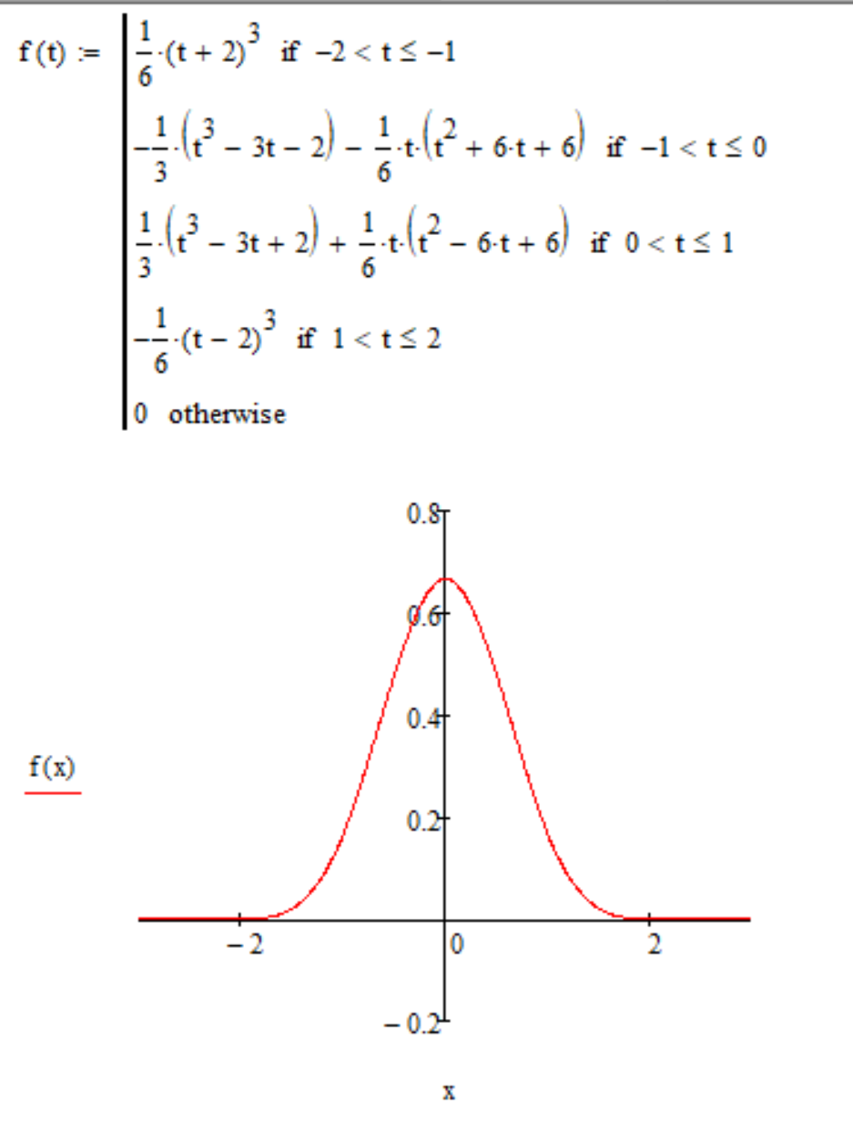

b)



  
Code listing:

clear all

close all

f = @(x) (1-abs(x)).*(abs(x)<1);

fs = 100; ts = 1/fs; t_0 = -2;

t_x = t_0:ts:2;

y = f(t_x);

t_c = -4:ts:4;

corr_data = xcorr(y,'normalized');

figure(2);hold on;

plot(t_x,y);plot(t_c,corr_data);

xlim([-2 2])

cr = @(t) corr_data(round((t-(t_0*2))*fs+1));

fps = 60;

T = 1/fps;

figure(1);hold on;

% подготовка матрицы и градиента

frm = getframe(gcf);

set(gcf,'color','w');

[im,map] = rgb2ind(frm.cdata,16);

im(1,1,1,length(t_x)) = 0;

map = [double(de2bi(0:7)); 1 0.5 0.5; 0.5 0 0; 1 1 0.5; 0.5 0.5 0; 0.5 0.5 1; 0 0 0.5; 0.5 1 0.5; 0 0.5 0;];

start = tic;

frame = tic;

for tau = (2*t_0):2*ts:(-2*t_0)

clf,hold on;set(gcf,'color','w');

t = t_0:ts:tau;

i = round((tau-(2*t_0))*(fs/2)+1);

if and(-2<=tau,tau<=-1)

% yellow

lim = -1:ts:(tau+1+(ts/2));

area(lim,max(f(lim),f(lim-tau)),'LineStyle','none','FaceColor','#FFFF80');

area(lim,min(f(lim),f(lim-tau)),'LineStyle','none','FaceColor','#808000');

end

if and(-1<=tau,tau<=0)

% red

lim = -1:ts:(tau+(ts/2));

area(lim,max(f(lim),f(lim-tau)),'LineStyle','none','FaceColor','#FF8080');

area(lim,min(f(lim),f(lim-tau)),'LineStyle','none','FaceColor','#800000');

% yellow

lim = tau:ts:(0+(ts/2));

area(lim,max(f(lim),f(lim-tau)),'LineStyle','none','FaceColor','#FFFF80');

area(lim,min(f(lim),f(lim-tau)),'LineStyle','none','FaceColor','#808000');

% blue

lim = 0:ts:(tau+1+(ts/2));

area(lim,max(f(lim),f(lim-tau)),'LineStyle','none','FaceColor','#8080FF');

area(lim,min(f(lim),f(lim-tau)),'LineStyle','none','FaceColor','#000080');

end

if and(0<=tau,tau<=1)

% red

lim = (tau-1):ts:(0+(ts/2));

area(lim,max(f(lim),f(lim-tau)),'LineStyle','none','FaceColor','#FF8080');

area(lim,min(f(lim),f(lim-tau)),'LineStyle','none','FaceColor','#800000');

% green

lim = 0:ts:(tau+(ts/2));

area(lim,max(f(lim),f(lim-tau)),'LineStyle','none','FaceColor','#80FF80');

area(lim,min(f(lim),f(lim-tau)),'LineStyle','none','FaceColor','#008000');

% blue

lim = tau:ts:(1+(ts/2));

area(lim,max(f(lim),f(lim-tau)),'LineStyle','none','FaceColor','#8080FF');

area(lim,min(f(lim),f(lim-tau)),'LineStyle','none','FaceColor','#000080');

end

if and(1<=tau,tau<=2)

% green

lim = (tau-1):ts:(1+(ts/2));

area(lim,max(f(lim),f(lim-tau)),'LineStyle','none','FaceColor','#80FF80');

area(lim,min(f(lim),f(lim-tau)),'LineStyle','none','FaceColor','#008000');

end

plot(t_x,f(t_x),'k','LineWidth',1,'DisplayName','triangular func.');

plot([tau tau],[0 1],'k--');plot(tau,cr(tau),'ko');

plot(t_x+tau,f(t_x),'k','LineWidth',1);

plot([0 0],[0 1],'k--');

plot(t,cr(t),'m','LineWidth',2,'DisplayName','autocorrelation func.');

xlim([-2 2])

ylim([0 1])

time = toc(frame);

frame = tic;

% pause(T-time);

frm = getframe(gcf);

img = frame2im(frm);

im(:,:,1,i) = rgb2ind(img,map);

% delete (ar);

% delete (point);

end

im(:,:,1,1) = rgb2ind(img,map);

imwrite(im,map,'exp_4.gif','DelayTime',T,'LoopCount',inf)

% avg_fps = length(x)/toc(start)